

**ABASAHEB GARWARE SENIOR COLLEGE, PUNE**

**DEPARTMENT OF STATISTICS**

**HEAD OF DEPARTMENT :- *SANDESH KHURADE SIR***

**PROJECT GUIDE :- *APPORVA PALI MAM***

* **PROJECT BY :-**



***Ishwari Sarde- 9775***

**Forecasting and analysing number of passengers of Pune METRO**

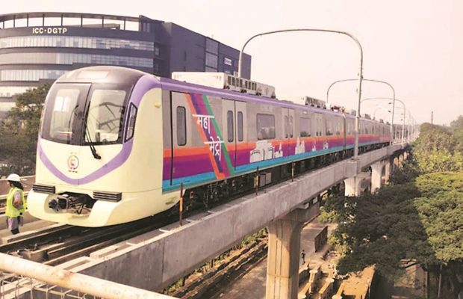

INDEX

* MOTIVATION
* ABSTRACT
* INTRODUCTION
* DATA COLLECTION
* MODEL FITTING -

1. AR MODEL
2. MA MODEL
3. ARMA MODEL
4. EXPONENTIAL SMOOTHING
5. HOLT WINTERS

* CONCLUSION
* LIMITATION
* REPORT

Motivation

Time series is a series of statistical observations arranged in chronological order. Study of time series help us to study past behaviors of variables under study, helps in forecasting the value of favorable variable and also helps in comparing two time related data. Time series can be helpful in many fields such as in business planning and decision making , inventory, scheduling of purchase and sales ,comparison between national income and cost of living and many more. These large amount of data when studied properly and analyzed carefully can be useful in many future predictions and may help to avoid losses over a period of time. We selected this project to get a glimpse of application of time series on metro. We can use time series to predict number of passengers and help in preplanned actions or tactics for increase or decrease in no. of passengers.

Abstract

In our daily life we come across many events that are time dependent. Time series a mathematical statistical tool to study series of these time related data in an order and is very useful in analyzing the periodic variations and helps in data based predictions. Time series is applicable in day to day life as well as in many fields such as accounting, manufacturing, weather forecast, sales forecasting etc

In this project we have applied various methods of time series on the newly build pune metro station which has completed a total of 10 stations. The response for metro was indecisive on whether it was a profitable or non-profitable initiative. Our main aim of this project is to try to predict the number of passengers to use metro over a period of time and help in developing schemes for the passengers before hand if there will be increase in the number also whether the frequency of trains should be increased in the stipulated time. Government is encouraging people to use public transport as much as possible . So on the behalf of this project we will be able to suggest the increase or decrease in passengers so the government will be able to use the data and reduce or increase the valuable sources that is being used.

This project uses time series to study number of passengers using metro everyday and thereby help in estimating the number of passengers that may use metro in future. From the data collected it is observed that Sundays have the highest number of passengers. This project uses Moving Average(MA),Exponential smoothening to smoothen out any cyclic, seasonal or irregular fluctuations. Auto regressive Models(AR) gives intuitive appeal by suggesting simple model which considers interlinks. Autoregressive integrated moving average (ARIMA) models predict future values based on past values and help in smoothening lagged AR values The Holt-Winters algorithm is used for forecasting and It is a time-series forecasting method.

**KEYWORDS**: Metro, Time Series, AR, MA, Exponential smoothening, ARIMA, Halt Winters.

**DATA COLLECTION** :- Metro office ,PUNE

Introduction

Whether travelling to work, going shopping, popping into town to meet with friends or getting home safely after a good night out, using public transport can be less stressful and more relaxing than driving. It also helps the environment. There are many benefits to using public transport. Here are some good reasons why you should ditch the car for public transport:

* you can enjoy a less stressful journey by letting someone else do the driving
* you don’t have to worry about finding a parking space
* it reduces congestion in towns and cities
* using public transport is cheaper than owning and operating a car
* no more sitting in traffic jams in rush hour thanks to bus lanes and other bus priority measures

However still people uses private transportations so to increase use of public transport various schemes or tactics should be used. Hence using time series we could predict increase in number of passengers and avoid any inconvenience. Researchers have previously used time series to predict various data and increase the efficiency of various sectors.

Objective

1. To use time series to predict and estimate the increase or decrease of number of customers.
2. To check the major variation in various days of week
3. To check whether there is a need to increase the frequency
4. What will be the predicted number of passengers?
5. Is there a need to increase schemes and awareness among people about metro



THE DATA

The following is the data that we collected from the official pune maha metro office regarding passengers in phugewadi and vanaz stations.

**PHUGEWADI**

|  |  |  |  |  |
| --- | --- | --- | --- | --- |
|  |  |  | passenger | |
| t1 | t2 | date | on date | cumultive |
|  | 21:00 | 3/6/2022 | 10570 | 10570 |
| 8:00 | 21:00 | 3/7/2022 | 5688 | 16258 |
| 8:00 | 21:00 | 3/8/2022 | 16653 | 32911 |
| 8:00 | 21:00 | 3/9/2022 | 5659 | 38570 |
| 8:00 | 21:00 | 3/10/2022 | 5566 | 44136 |
| 8:00 | 21:00 | 3/11/2022 | 4038 | 48174 |
| 8:00 | 21:00 | 3/12/2022 | 11189 | 59363 |
| 8:00 | 22:00 | 3/13/2022 | 22814 | 82177 |
| 8:00 | 22:00 | 3/14/2022 | 5301 | 87478 |
| 8:00 | 21:00 | 3/15/2022 | 4182 | 91660 |
| 8:00 | 21:00 | 3/16/2022 | 2912 | 94572 |
| 8:00 | 21:00 | 3/17/2022 | 2775 | 97347 |
| 8:00 | 21:00 | 3/18/2022 | 5526 | 102873 |
| 8:00 | 21:00 | 3/19/2022 | 5461 | 108334 |
| 8:00 | 22:00 | 3/20/2022 | 11929 | 120263 |
| 8:00 | 22:00 | 3/21/2022 | 2200 | 122463 |
| 8:00 | 21:00 | 3/22/2022 | 2241 | 124704 |
| 8:00 | 21:00 | 3/23/2022 | 1964 | 126668 |
| 8:00 | 21:00 | 3/24/2022 | 2583 | 129251 |
| 8:00 | 21:00 | 3/25/2022 | 1849 | 131100 |
| 8:00 | 21:00 | 3/26/2022 | 4070 | 135170 |
| 8:00 | 21:00 | 3/27/2022 | 8023 | 143193 |
| 8:00 | 21:00 | 3/28/2022 | 1944 | 145137 |
| 8:00 | 21:00 | 3/29/2022 | 3057 | 148194 |
|  |  |  |  |  |

|  |  |  |  |  |  |  |  |  |  |  |  |  |  |
| --- | --- | --- | --- | --- | --- | --- | --- | --- | --- | --- | --- | --- | --- |
| Mann-Kendall Test  To Test:  H0: There is no trend present in data  Vs  H1: There is trend( increasing or decreasing )present in data   |  |  |  |  | | --- | --- | --- | --- | | **Stations** | **tau** | **P value** | **Decision(<0.05)** | | **Phugewadi** | -0.457 | 0.0019316 | H0 Rejected | | **Vanaz** | -0.551 | 0.00018006 | H0 Rejected |   **Interpretation:** As H0 is rejected in both stations a trend is present. |  |

VANAZ

|  |  |  |  |  |
| --- | --- | --- | --- | --- |
|  |  |  |  | passenger |
| t1 | t2 | date | on date | cumultive |
|  | 21:00 | 3/6/2022 | 27182 | 27182 |
| 8:00 | 21:00 | 3/7/2022 | 21917 | 49099 |
| 8:00 | 21:00 | 3/8/2022 | 25417 | 74516 |
| 8:00 | 21:00 | 3/9/2022 | 14664 | 89180 |
| 8:00 | 21:00 | 3/10/2022 | 14308 | 103488 |
| 8:00 | 21:00 | 3/11/2022 | 12580 | 116068 |
| 8:00 | 21:00 | 3/12/2022 | 30187 | 146255 |
| 8:00 | 22:00 | 3/13/2022 | 44536 | 190791 |
| 8:00 | 22:00 | 3/14/2022 | 12548 | 203339 |
| 8:00 | 21:00 | 3/15/2022 | 10108 | 213447 |
| 8:00 | 21:00 | 3/16/2022 | 8832 | 222279 |
| 8:00 | 21:00 | 3/17/2022 | 6727 | 229006 |
| 8:00 | 21:00 | 3/18/2022 | 12998 | 242004 |
| 8:00 | 21:00 | 3/19/2022 | 15384 | 257388 |
| 8:00 | 22:00 | 3/20/2022 | 26121 | 283509 |
| 8:00 | 22:00 | 3/21/2022 | 6475 | 289984 |
| 8:00 | 21:00 | 3/22/2022 | 6401 | 296385 |
| 8:00 | 21:00 | 3/23/2022 | 6336 | 302721 |
| 8:00 | 21:00 | 3/24/2022 | 6321 | 309042 |
| 8:00 | 21:00 | 3/25/2022 | 5780 | 314822 |
| 8:00 | 21:00 | 3/26/2022 | 11179 | 326001 |
| 8:00 | 21:00 | 3/27/2022 | 19272 | 345273 |
| 8:00 | 21:00 | 3/28/2022 | 6096 | 351369 |
| 8:00 | 21:00 | 3/29/2022 | 4959 | 356328 |

|  |  |  |
| --- | --- | --- |
|  |  |  |

**Phugewadi station**

Graph fitted distributions:

**Discrete**

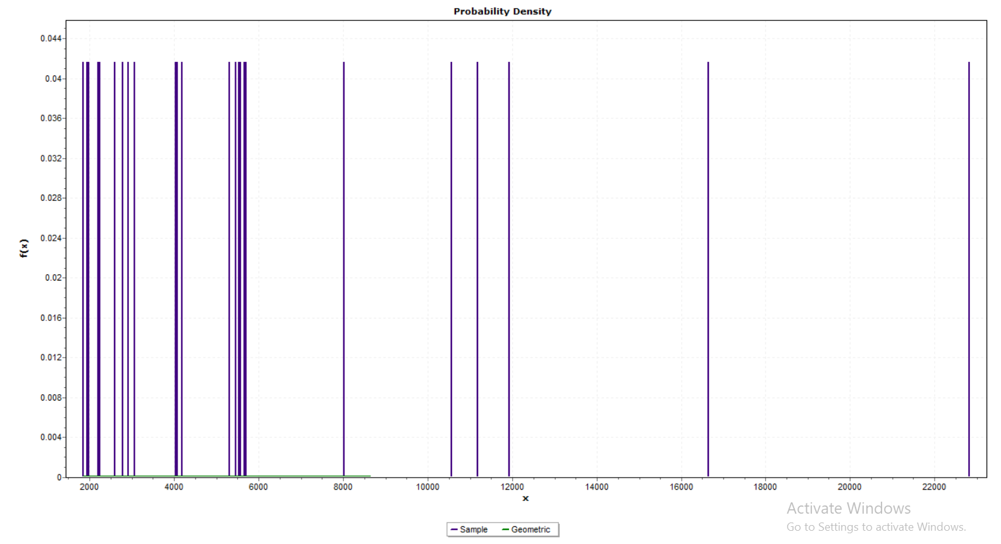

**P=1.6192E-4**

**Continous**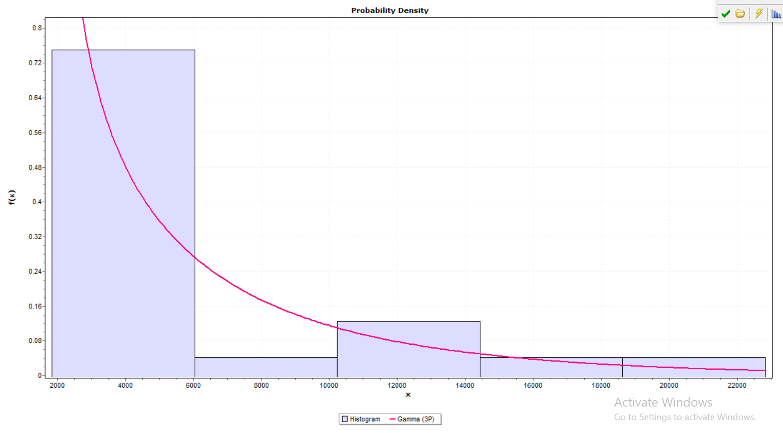

|  |  |  |  |
| --- | --- | --- | --- |
| **DISCRETE** | **GEOMETRIC** | **PARAMETER**  **P=1.6192E-4** | **STATISTIC=0.21721** |
| **CONTINOUS** | GAMMA(3P) | PARAMETER  ALPHA=0.6057  BETA=6631.4  GAMMA=1849 | STATISTIC=0.09487 |

Auto-regressive model

AR (1) – **Yt=a1 Yt-1 + a2Yt-2+……+akYt-k+b+ε**

Various aic of the given data

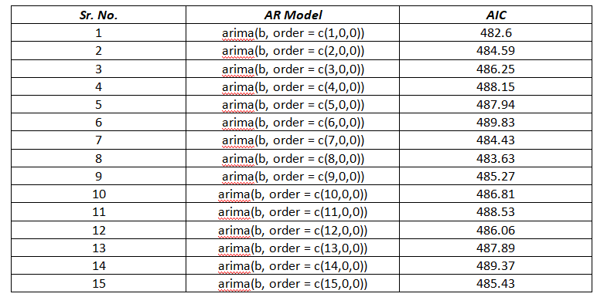

optimum model :arima(b, order = c(1,0,0))

aic = 482.6

|  |  |  |
| --- | --- | --- |
| ***Sr. No.*** | ***Observed*** | ***Expected*** |
| 1 | 10570 | 6266.401 |
| 2 | 5688 | 7017.678 |
| 3 | 16653 | 6092.39 |
| 4 | 5659 | 8170.592 |
| 5 | 5566 | 6086.893 |
| 6 | 4038 | 6069.267 |
| 7 | 11189 | 5779.664 |
| 8 | 22814 | 7134.997 |
| 9 | 5301 | 9338.29 |
| 10 | 4182 | 6019.041 |
| 11 | 2912 | 5806.957 |
| 12 | 2775 | 5566.253 |
| 13 | 5526 | 5540.287 |
| 14 | 5461 | 6061.686 |
| 15 | 11929 | 6049.366 |
| 16 | 2200 | 7275.25 |
| 17 | 2241 | 5431.307 |
| 18 | 1964 | 5439.078 |
| 19 | 2583 | 5386.578 |
| 20 | 1849 | 5503.897 |
| 21 | 4070 | 5364.782 |
| 22 | 8023 | 5785.729 |
| 23 | 1944 | 6534.944 |
| 24 | 3057 | 5382.787 |
| 25 |  | 5593.735 |
| 26 |  | 6074.524 |
| 27 |  | 6165.648 |
| 28 |  | 6182.919 |
| 29 |  | 6186.192 |
| 30 |  | 6186.812 |

Split train test

|  |  |  |
| --- | --- | --- |
| ***Sr. No.*** | ***Observed*** | ***Expected*** |
| 1 | 10570 | 6613.521 |
| 2 | 5688 | 7273.025 |
| 3 | 16653 | 6392.534 |
| 4 | 5659 | 8370.12 |
| 5 | 5566 | 6387.304 |
| 6 | 4038 | 6370.531 |
| 7 | 11189 | 6094.95 |
| 8 | 22814 | 7384.664 |
| 9 | 5301 | 9481.284 |
| 10 | 4182 | 6322.737 |
| 11 | 2912 | 6120.921 |
| 12 | 2775 | 5891.87 |
| 13 | 5526 | 5867.162 |
| 14 | 5461 | 6363.317 |
| 15 | 11929 | 6351.594 |
| 16 | 2200 | 7518.126 |
| 17 | 2241 | 5763.458 |
| 18 | 1964 | 5770.853 |
| 19 | 2583 | 5720.895 |
| 20 | 1849 | 5832.534 |
| 21 | 4070 | 5700.154 |
| 22 | 8023 | 6394.726 |
| 23 | 1944 | 6519.996 |
| 24 | 3057 | 6542.588 |

MA model

|  |  |  |
| --- | --- | --- |
| ***Sr. No.*** | ***MA model*** | ***AIC*** |
| 1 | arima(b, order = c(0,0,1)) | 482.62 |
| 2 | arima(b, order = c(0,0,2)) | 484.54 |
| 3 | arima(b, order = c(0,0,3)) | 484.84 |
| 4 | arima(b, order = c(0,0,4)) | 485.90 |
| 5 | arima(b, order = c(0,0,5)) | 482.20 |
| 6 | arima(b, order = c(0,0,6)) | 484.14 |
| 7 | arima(b, order = c(0,0,7)) | 483.42 |
| 8 | arima(b, order = c(0,0,8)) | 485.03 |
| 9 | arima(b, order = c(0,0,9)) | 485.94 |
| 10 | arima(b, order = c(0,0,10)) | 487.52 |
| 11 | arima(b, order = c(0,0,11)) | 489.44 |
| 12 | arima(b, order = c(0,0,12)) | 489.85 |
| 13 | arima(b, order = c(0,0,13)) | 491.57 |
| 14 | arima(b, order = c(0,0,14)) | 493.51 |
| 15 | arima(b, order = c(0,0,15)) | 494.28 |
| 16 | arima(b, order = c(0,0,16)) | 495.46 |
| 17 | arima(b, order = c(0,0,17)) | 497.14 |
| 18 | arima(b, order = c(0,0,18)) | 498.81 |
| 19 | arima(b, order = c(0,0,19)) | 500.81 |
| 20 | arima(b, order = c(0,0,20)) | 502.66 |
| 21 | arima(b, order = c(0,0,21)) | 503.44 |
| 22 | arima(b, order = c(0,0,22)) | 505.38 |
| 23 | arima(b, order = c(0,0,23)) | 507.34 |
| 24 | arima(b, order = c(0,0,24)) | 509.30 |
| 25 | arima(b, order = c(0,0,25)) | 510.88 |

|  |  |  |
| --- | --- | --- |
| ***Sr. No.*** | ***Observed*** | ***Expected*** |
| 1 | 10570 | 6266.401 |
| 2 | 5688 | 7017.678 |
| 3 | 16653 | 6092.39 |
| 4 | 5659 | 8170.592 |
| 5 | 5566 | 6086.893 |
| 6 | 4038 | 6069.267 |
| 7 | 11189 | 5779.664 |
| 8 | 22814 | 7134.997 |
| 9 | 5301 | 9338.29 |
| 10 | 4182 | 6019.041 |
| 11 | 2912 | 5806.957 |
| 12 | 2775 | 5566.253 |
| 13 | 5526 | 5540.287 |
| 14 | 5461 | 6061.686 |
| 15 | 11929 | 6049.366 |
| 16 | 2200 | 7275.25 |
| 17 | 2241 | 5431.307 |
| 18 | 1964 | 5439.078 |
| 19 | 2583 | 5386.578 |
| 20 | 1849 | 5503.897 |
| 21 | 4070 | 5364.782 |
| 22 | 8023 | 5785.729 |
| 23 | 1944 | 6534.944 |
| 24 | 3057 | 5382.787 |
| 25 |  | 5593.735 |
| 26 |  | 6074.524 |
| 27 |  | 6165.648 |
| 28 |  | 6182.919 |
| 29 |  | 6186.192 |
| 30 |  | 6186.812 |

Split train test

|  |  |  |
| --- | --- | --- |
| ***Sr. No.*** | ***Observed*** | ***Expected*** |
| 1 | 10570 | 7890.384 |
| 2 | 5688 | 6710.642 |
| 3 | 16653 | 7982.151 |
| 4 | 5659 | 7579.936 |
| 5 | 5566 | 4543.744 |
| 6 | 4038 | 6187.67 |
| 7 | 11189 | 7749.082 |
| 8 | 22814 | 15378.09 |
| 9 | 5301 | 6361.361 |
| 10 | 4182 | 3081.134 |
| 11 | 2912 | 3787.109 |
| 12 | 2775 | 9157.608 |
| 13 | 5526 | 10235.85 |
| 14 | 5461 | 6926.017 |
| 15 | 11929 | 10669.31 |
| 16 | 2200 | 6205.073 |
| 17 | 2241 | -498.517 |
| 18 | 1964 | 3445.796 |
| 19 | 2583 | 5176.931 |
| 20 | 1849 | 5392.639 |
| 21 | 4070 | 4036.992 |
| 22 | 8023 | 10597.74 |
| 23 | 1944 | 5711.391 |
| 24 | 3057 | 3410.797 |

Arima

Φ(B)Xt = Θ(B)ωt

|  |  |
| --- | --- |
| **Phugewadi** | |
| ***Arima Model*** | ***AIC*** |
| arima(x = t, order = c(1, 0, 5)) | 484.11 |
| arima(x = t, order = c(2, 0, 5)) | 484.39 |
| arima(x = t, order = c(3, 0, 6)) | 483.43 |
| arima(x = t, order = c(4, 0, 6)) | 485.07 |
| arima(x = t, order = c(5, 0, 1)) | 485.57 |
| arima(x = t, order = c(6, 0, 4)) | 486.95 |
| arima(x = t, order = c(7, 0, 1)) | 484.54 |
| arima(x = t, order = c(8, 0, 1)) | 481.87 |
| arima(x = t, order = c(9, 0, 1)) | 483.87 |
| arima(x = t, order = c(10, 0, 1)) | 485.16 |

Phugewadi:

Model fitting-

**MA (1) =** Xt = µ + wt + θ1 wt-1+ θ2 wt-2+…..+ θq wt-q

Model = arima(x = t, order = c(8, 0, 1))

AIC = 508.52

|  |  |  |
| --- | --- | --- |
|  | expected | observed |
| 1 | 10570 | 7859.197 |
| 2 | 5688 | 6341.292 |
| 3 | 16653 | 10169.31 |
| 4 | 5659 | 6705.862 |
| 5 | 5566 | 5789.736 |
| 6 | 4038 | 5665.863 |
| 7 | 11189 | 6418.853 |
| 8 | 22814 | 16146.11 |
| 9 | 5301 | 6855.14 |
| 10 | 4182 | 7986.39 |
| 11 | 2912 | 2387.924 |
| 12 | 2775 | 5088.539 |
| 13 | 5526 | 7105.527 |
| 14 | 5461 | 4103.546 |
| 15 | 11929 | 13083.25 |
| 16 | 2200 | 1202.797 |
| 17 | 2241 | -1962.13 |
| 18 | 1964 | 1220.191 |
| 19 | 2583 | 1628.97 |
| 20 | 1849 | 6616.362 |
| 21 | 4070 | 2475.776 |
| 22 | 8023 | 9541.87 |
| 23 | 1944 | 3303.549 |
| 24 | 3057 | 2565.559 |
| 25 |  | 4572.09 |
| 26 |  | 6849.646 |
| 27 |  | 8014.572 |
| 28 |  | 6609.864 |
| 29 |  | 10142.08 |
| 30 |  | 7070.526 |

Split, Train and Test-

|  |  |  |
| --- | --- | --- |
|  | b | D |
| 1 | 10570 | 7936.762 |
| 2 | 5688 | 6416.803 |
| 3 | 16653 | 10060.53 |
| 4 | 5659 | 6751.299 |
| 5 | 5566 | 5568.65 |
| 6 | 4038 | 5622.045 |
| 7 | 11189 | 6327.922 |
| 8 | 22814 | 16225.19 |
| 9 | 5301 | 6676.673 |
| 10 | 4182 | 7517.383 |
| 11 | 2912 | 2275.755 |
| 12 | 2775 | 5072.136 |
| 13 | 5526 | 6682.753 |
| 14 | 5461 | 3277.888 |
| 15 | 11929 | 13534.28 |
| 16 | 2200 | 2068.155 |
| 17 | 2241 | -1699.73 |
| 18 | 1964 | 1684.34 |
| 19 | 2583 | 1927.791 |
| 20 | 1849 | 7002.485 |
| 21 | 4070 | 2412.454 |
| 22 | 8023 | 10144.62 |
| 23 | 1944 | 5422.952 |
| 24 | 3057 | 3413.532 |

Exponential smoothing

|  |  |  |  |
| --- | --- | --- | --- |
| sr. no. | observed | expected | error squared |
| 1 | 10570 | 10570 | 0 |
| 2 | 5688 | 6664.4 | 953357 |
| 3 | 16653 | 14655.28 | 3990885 |
| 4 | 5659 | 7458.256 | 3237322 |
| 5 | 5566 | 5944.451 | 143225.2 |
| 6 | 4038 | 4419.29 | 145382.1 |
| 7 | 11189 | 9835.058 | 1833159 |
| 8 | 22814 | 20218.21 | 6738115 |
| 9 | 5301 | 8284.442 | 8900926 |
| 10 | 4182 | 5002.488 | 673200.6 |
| 11 | 2912 | 3330.098 | 174805.9 |
| 12 | 2775 | 2886.02 | 12325.44 |
| 13 | 5526 | 4998.004 | 278779.8 |
| 14 | 5461 | 5368.401 | 8574.575 |
| 15 | 11929 | 10616.88 | 1721659 |
| 16 | 2200 | 3883.376 | 2833755 |
| 17 | 2241 | 2569.475 | 107895.8 |
| 18 | 1964 | 2085.095 | 14664 |
| 19 | 2583 | 2483.419 | 9916.376 |
| 20 | 1849 | 1975.884 | 16099.55 |
| 21 | 4070 | 3651.177 | 175412.7 |
| 22 | 8023 | 7148.635 | 764514.2 |
| 23 | 1944 | 2984.927 | 1083529 |
| 24 | 3057 | 3042.585 | 207.7922 |
| 25 |  | 3042.585 |  |
| 26 |  | 3042.585 |  |
| 27 |  | 3042.585 |  |
| 28 |  | 3042.585 |  |
| 29 |  | 3042.585 |  |
|  |  | 3042.585 |  |

Split train test

|  |  |  |
| --- | --- | --- |
| ***Sr. No.*** | ***Observed*** | ***Expected*** |
| 1 | 10570 | 10570 |
| 2 | 5688 | 6664.4 |
| 3 | 16653 | 14655.28 |
| 4 | 5659 | 7458.256 |
| 5 | 5566 | 5944.451 |
| 6 | 4038 | 4419.29 |
| 7 | 11189 | 9835.058 |
| 8 | 22814 | 20218.21 |
| 9 | 5301 | 8284.442 |
| 10 | 4182 | 5002.488 |
| 11 | 2912 | 3330.098 |
| 12 | 2775 | 2886.02 |
| 13 | 5526 | 4998.004 |
| 14 | 5461 | 5368.401 |
| 15 | 11929 | 10616.88 |
| 16 | 2200 | 3883.376 |
| 17 | 2241 | 2569.475 |
| 18 | 1964 | 2085.095 |
| 19 | 2583 | 2483.419 |
| 20 | 1849 | 1975.884 |
| 21 | 4070 | 1975.884 |
| 22 | 8023 | 1975.884 |
| 23 | 1944 | 1975.884 |
| 24 | 3057 | 1975.884 |

|  |  |  |
| --- | --- | --- |
| ***Sr. No.*** | ***Observed*** | ***Expected*** |
| 1 | 10570 |  |
| 2 | 5688 |  |
| 3 | 16653 | 806 |
| 4 | 5659 | 6421.776 |
| 5 | 5566 | 2990.328 |
| 6 | 4038 | 1676.278 |
| 7 | 11189 | 538.3895 |
| 8 | 22814 | 5182.925 |
| 9 | 5301 | 15766.15 |
| 10 | 4182 | 9913.189 |
| 11 | 2912 | 5904.605 |
| 12 | 2775 | 3002.836 |
| 13 | 5526 | 1563.226 |
| 14 | 5461 | 2871.548 |
| 15 | 11929 | 3759.207 |
| 16 | 2200 | 8663.131 |
| 17 | 2241 | 4881.861 |
| 18 | 1964 | 2834.952 |
| 19 | 2583 | 1634.575 |
| 20 | 1849 | 1531.942 |
| 21 | 4070 | 1128.118 |
| 22 | 8023 | 2502.229 |
| 23 | 1944 | 5947.803 |
| 24 | 3057 | 3765.243 |
| 25 |  | 3271.66 |
| 26 |  | 3159.837 |
| 27 |  | 3048.014 |
| 28 |  | 2936.191 |
| 29 |  | 2824.368 |
| 30 |  | 2712.545 |

Split train test

|  |  |  |
| --- | --- | --- |
| ***Sr. No.*** | ***Observed*** | ***Expected*** |
| 1 | 10570 |  |
| 2 | 5688 |  |
| 3 | 16653 | 806 |
| 4 | 5659 | 6613.361 |
| 5 | 5566 | 3081.772 |
| 6 | 4038 | 1749.538 |
| 7 | 11189 | 597.864 |
| 8 | 22814 | 5334.613 |
| 9 | 5301 | 16050.5 |
| 10 | 4182 | 9924.588 |
| 11 | 2912 | 5823.314 |
| 12 | 2775 | 2909.195 |
| 13 | 5526 | 1501.986 |
| 14 | 5461 | 2882.749 |
| 15 | 11929 | 3794.67 |
| 16 | 2200 | 8778.805 |
| 17 | 2241 | 4862.022 |
| 18 | 1964 | 2787.037 |
| 19 | 2583 | 1595.031 |
| 20 | 1849 | 1521.043 |
| 21 | 4070 | 1126.178 |
| 22 | 8023 | 551.3641 |
| 23 | 1944 | -23.4498 |
| 24 | 3057 | -598.264 |

Holt

|  |  |  |
| --- | --- | --- |
| ***Sr. No.*** | ***Observed*** | ***Expected*** |
| 1 | 10570 | 10215.56 |
| 2 | 5688 | 9867.88 |
| 3 | 16653 | 9519.279 |
| 4 | 5659 | 9172.632 |
| 5 | 5566 | 8824.485 |
| 6 | 4038 | 8476.02 |
| 7 | 11189 | 8126.959 |
| 8 | 22814 | 7779.017 |
| 9 | 5301 | 7433.938 |
| 10 | 4182 | 7086.813 |
| 11 | 2912 | 6739.299 |
| 12 | 2775 | 6391.281 |
| 13 | 5526 | 6042.903 |
| 14 | 5461 | 5694.798 |
| 15 | 11929 | 5346.698 |
| 16 | 2200 | 5000.018 |
| 17 | 2241 | 4652.048 |
| 18 | 1964 | 4303.862 |
| 19 | 2583 | 3955.437 |
| 20 | 1849 | 3606.969 |
| 21 | 4070 | 3258.273 |
| 22 | 8023 | 2909.936 |
| 23 | 1944 | 2562.596 |
| 24 | 3057 | 2214.584 |
| 25 |  | 1866.815 |
| 26 |  | 1518.958 |
| 27 |  | 1171.1 |
| 28 |  | 823.2421 |
| 29 |  | 475.3845 |
| 30 |  | 127.5268 |

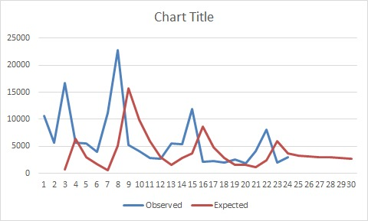

Split train test

|  |  |  |
| --- | --- | --- |
| ***Sr. No.*** | ***Observed*** | ***Expected*** |
| 1 | 10570 | 10633.27 |
| 2 | 5688 | 10201.27 |
| 3 | 16653 | 9766.833 |
| 4 | 5659 | 9338.176 |
| 5 | 5566 | 8904.434 |
| 6 | 4038 | 8470.51 |
| 7 | 11189 | 8035.655 |
| 8 | 22814 | 7604.501 |
| 9 | 5301 | 7180.251 |
| 10 | 4182 | 6748.184 |
| 11 | 2912 | 6315.554 |
| 12 | 2775 | 5882.209 |
| 13 | 5526 | 5448.686 |
| 14 | 5461 | 5016.592 |
| 15 | 11929 | 4584.707 |
| 16 | 2200 | 4156.637 |
| 17 | 2241 | 3724.218 |
| 18 | 1964 | 3291.863 |
| 19 | 2583 | 2859.444 |
| 20 | 1849 | 2427.467 |
| 21 | 4070 | 1995.297 |
| 22 | 8023 | 1563.385 |
| 23 | 1944 | 1131.474 |
| 24 | 3057 | 699.5623 |

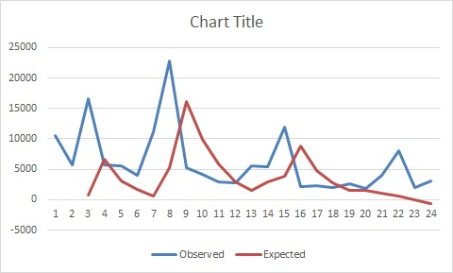

VANAZ

Fitted graph:

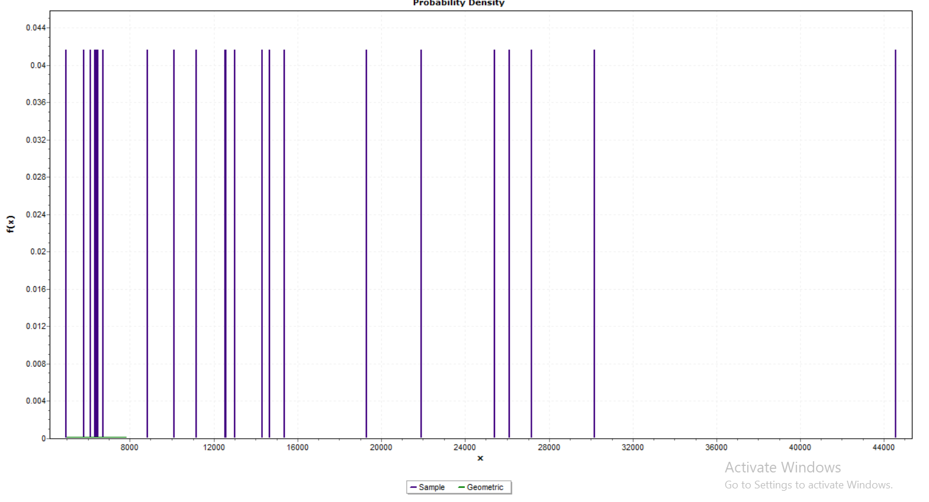

P=6.734E-04

**CONTINOUS**

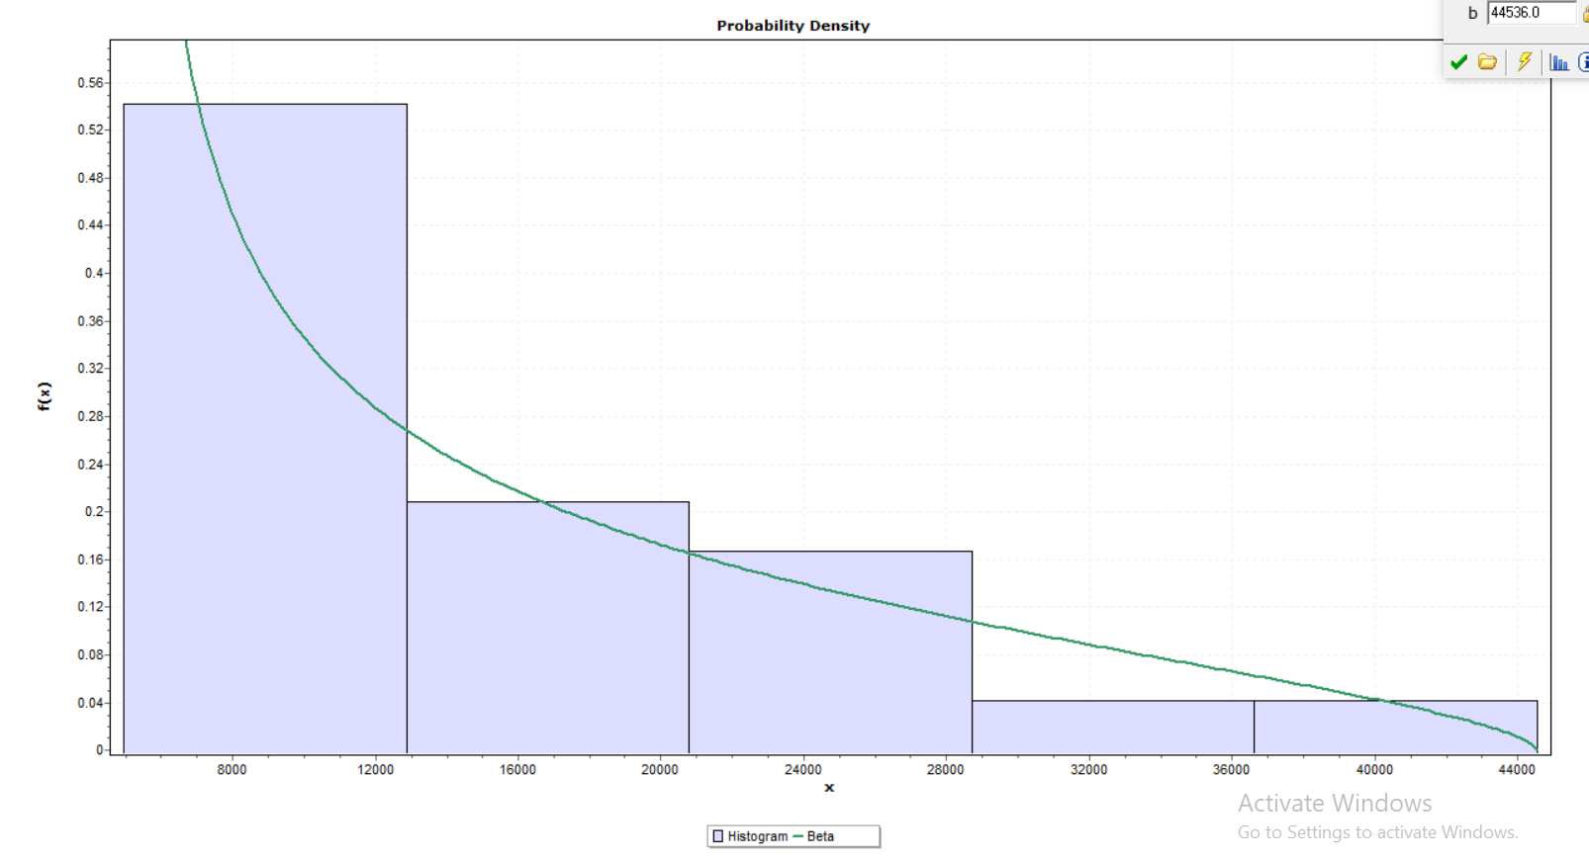

STATISTIC:0.0976

|  |  |  |  |
| --- | --- | --- | --- |
| **DISCRETE** | **GEOMETRIC** | **PARAMRTER**  **P=6.7349E-5** | **STATISTIC=0.24232** |
| **CONTINOUS** | BETA | PARAMETER  ALPHA1=0.5503  ALPHA2=1.599  A=4959.0,b=44536 | STATISTIC=0.0976 |

Auto regressive model vanaz

Vanaz:

1. **AR MODEL**

**AR (1) – Yt=a1 Yt-1 + a2Yt-2+……+akYt-k+b+ε**

|  |  |  |
| --- | --- | --- |
| SR NO. | ORDER | AIC |
| 1 | arima(b, order = c(1,0,0)) | 510.62 |
| 2 | arima(b, order = c(2,0,0)) | 511.96 |
| 3 | arima(b, order = c(3,0,0)) | 513.96 |
| 4 | arima(b, order = c(4,0,0)) | 515.92 |
| 5 | arima(b, order = c(5,0,0)) | 517.06 |
| 6 | arima(b, order = c(6,0,0)) | 518.42 |
| 7 | arima(b, order = c(7,0,0)) | 513.04 |
| 8 | arima(b, order = c(8,0,0)) | 510.16 |
| 9 | arima(b, order = c(9,0,0)) | 511.65 |
| 10 | arima(b, order = c(10,0,0)) | 513.46 |
| 11 | arima(b, order = c(11,0,0)) | 514.91 |
| 12 | arima(b, order = c(12,0,0)) | 514.04 |
| 13 | arima(b, order = c(13,0,0)) | 516.02 |
| 14 | arima(b, order = c(14,0,0)) | 518.02 |
| 15 | arima(b, order = c(15,0,0)) | 517.42 |

Optimum model :arima(b, order = c(8,0,0))

Aic = 510.16

|  |  |
| --- | --- |
|  |  |

|  |  |  |  |  |  |  |  |  |  |  |  |  |  |  |  |  |  |  |  |  |  |  |  |  |  |  |  |  |  |  |  |  |  |  |  |  |  |  |  |  |  |  |  |  |  |  |  |  |  |  |  |  |  |  |  |  |  |  |  |  |  |  |  |  |  |  |  |  |  |  |  |  |  |  |  |  |  |  |  |  |  |  |  |  |  |  |  |  |  |  |  |  |  |  |  |  |  |  |  |
| --- | --- | --- | --- | --- | --- | --- | --- | --- | --- | --- | --- | --- | --- | --- | --- | --- | --- | --- | --- | --- | --- | --- | --- | --- | --- | --- | --- | --- | --- | --- | --- | --- | --- | --- | --- | --- | --- | --- | --- | --- | --- | --- | --- | --- | --- | --- | --- | --- | --- | --- | --- | --- | --- | --- | --- | --- | --- | --- | --- | --- | --- | --- | --- | --- | --- | --- | --- | --- | --- | --- | --- | --- | --- | --- | --- | --- | --- | --- | --- | --- | --- | --- | --- | --- | --- | --- | --- | --- | --- | --- | --- | --- | --- | --- | --- | --- | --- | --- | --- |
| |  |  |  | | --- | --- | --- | | sr. no. | observed | Expected | | 1 | 27182 | 18817.75 | | 2 | 21917 | 20325.3 | | 3 | 25417 | 17980.69 | | 4 | 14664 | 16976.53 | | 5 | 14308 | 12507.69 | | 6 | 12580 | 15208.83 | | 7 | 30187 | 19089.93 | | 8 | 44536 | 31353.35 | | 9 | 12548 | 25089.17 | | 10 | 10108 | 10311.24 | | 11 | 8832 | 8385.549 | | 12 | 6727 | 11872.27 | | 13 | 12998 | 13116.4 | | 14 | 15384 | 20180.45 | | 15 | 26121 | 24988.89 | | 16 | 6475 | 3845.511 | | 17 | 6401 | 3746.162 | | 18 | 6336 | 12860.61 | | 19 | 6321 | 7279.516 | | 20 | 5780 | 16817.41 | | 21 | 11179 | 7898.316 | | 22 | 19272 | 21051.22 | | 23 | 6096 | 5958.041 | | 24 | 4959 | 6947.101 | |  |  | 10322.44 | |  |  | 12582.2 | |  |  | 14400.4 | |  |  | 15133.7 | |  |  | 19391.5 | |  |  | 10327.8 | | MSE=35237206.8 |  |  | | |  |  |
|  | |  |  |
|  | |  |  |
|  | |  |  |
|  | |  |  |
|  | |  |  |
|  | |  |  |
|  | |  |  |
|  | |  |  |
|  | |  |  |
|  | |  |  |
|  | |  |  |
|  | |  |  |
|  | |  |  |
|  | |  |  |
|  | |  |  |
|  | |  |  |
|  | |  |  |
|  | |  |  |
|  | |  |  |
| AR  **Yt=a1 Yt-1 + a2Yt-2+……+akYt-k+b+ε**   |  |  |  | | --- | --- | --- | | Sr. No. | Observed | Expected | | 1 | 27182 | 18714.7 | | 2 | 21917 | 20360.24 | | 3 | 25417 | 18273.76 | | 4 | 14664 | 17220.87 | | 5 | 14308 | 12910.68 | | 6 | 12580 | 15257.98 | | 7 | 30187 | 18508.11 | | 8 | 44536 | 31406.83 | | 9 | 12548 | 25123.49 | | 10 | 10108 | 10105.27 | | 11 | 8832 | 8371.397 | | 12 | 6727 | 11762.27 | | 13 | 12998 | 12739.34 | | 14 | 15384 | 18827.03 | | 15 | 26121 | 25361.57 | | 16 | 6475 | 4395.814 | | 17 | 6401 | 3572.242 | | 18 | 6336 | 13251.28 | | 19 | 6321 | 7030.99 | | 20 | 5780 | 16973.17 | | 21 | 11179 | 7147.676 | | 22 | 19272 | 18821.55 | | 23 | 6096 | 7300.778 | | 24 | 4959 | 7325.191 | | |  |  |
|  | |  |  |
|  | |  |  |
|  | |  |  |
|  | |  |  |
|  |
|  |
|  |
|  |
|  |
|  |

MA MODELS:

2)MA MODEL

Xt = µ + wt + θ1 wt-1+ θ2 wt-2+…..+ θq wt-q

|  |  |  |
| --- | --- | --- |
| SR NO. | ORDER | AIC |
| 1 | arima(b, order = c(0,0,1)) | 510.1 |
| 2 | arima(b, order = c(0,0,2)) | 512.05 |
| 3 | arima(b, order = c(0,0,3)) | 514.04 |
| 4 | arima(b, order = c(0,0,4)) | 514.58 |
| 5 | arima(b, order = c(0,0,5)) | 512.5 |
| 6 | arima(b, order = c(0,0,6)) | 513.5 |
| 7 | arima(b, order = c(0,0,7)) | 512.76 |
| 8 | arima(b, order = c(0,0,8)) | 512.36 |
| 9 | arima(b, order = c(0,0,9)) | 513.56 |
| 10 | arima(b, order = c(0,0,10)) | 515.41 |
| 11 | arima(b, order = c(0,0,11)) | 517.29 |
| 12 | arima(b, order = c(0,0,12)) | 518.14 |
| 13 | arima(b, order = c(0,0,13)) | 520.12 |
| 14 | arima(b, order = c(0,0,14)) | 521.89 |
| 15 | arima(b, order = c(0,0,15)) | 522.78 |
| 16 | arima(b, order = c(0,0,16)) | 524.59 |
| 17 | arima(b, order = c(0,0,17)) | 526.02 |

optimum model : arima(b, order = c(0,0,1))

AIC=510.1

2)MA Model

Xt = µ + wt + θ1 wt-1+ θ2 wt-2+…..+ θq wt-q

|  |  |  |
| --- | --- | --- |
| sr. no. | observed | Expected |
| 1 | 27182 | 18817.75 |
| 2 | 21917 | 20325.3 |
| 3 | 25417 | 17980.69 |
| 4 | 14664 | 16976.53 |
| 5 | 14308 | 12507.69 |
| 6 | 12580 | 15208.83 |
| 7 | 30187 | 19089.93 |
| 8 | 44536 | 31353.35 |
| 9 | 12548 | 25089.17 |
| 10 | 10108 | 10311.24 |
| 11 | 8832 | 8385.549 |
| 12 | 6727 | 11872.27 |
| 13 | 12998 | 13116.4 |
| 14 | 15384 | 20180.45 |
| 15 | 26121 | 24988.89 |
| 16 | 6475 | 3845.511 |
| 17 | 6401 | 3746.162 |
| 18 | 6336 | 12860.61 |
| 19 | 6321 | 7279.516 |
| 20 | 5780 | 16817.41 |
| 21 | 11179 | 7898.316 |
| 22 | 19272 | 21051.22 |
| 23 | 6096 | 5958.041 |
| 24 | 4959 | 6947.101 |
| 25 |  | 12707.79 |
| 26 |  | 14975.76 |
| 27 |  | 14975.76 |
| 28 |  | 14975.76 |
| 29 |  | 14975.76 |
| 30 |  | 14975.76 |

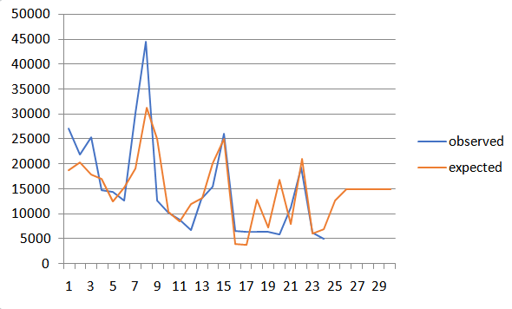

MA

Xt = µ + wt + θ1 wt-1+ θ2 wt-2+…..+ θq wt-q

|  |  |  |
| --- | --- | --- |
| Sr. No. | Observed | Expected |
| 1 | 27182 | 16808.31 |
| 2 | 21917 | 20086.73 |
| 3 | 25417 | 16649.81 |
| 4 | 14664 | 19726.73 |
| 5 | 14308 | 13547.9 |
| 6 | 12580 | 16155.09 |
| 7 | 30187 | 14212.99 |
| 8 | 44536 | 22971.73 |
| 9 | 12548 | 25476.42 |
| 10 | 10108 | 10022.14 |
| 11 | 8832 | 15853.13 |
| 12 | 6727 | 12668.88 |
| 13 | 12998 | 13152.43 |
| 14 | 15384 | 15745.47 |
| 15 | 26121 | 15652.71 |
| 16 | 6475 | 20504.94 |
| 17 | 6401 | 9528.614 |
| 18 | 6336 | 14413.35 |
| 19 | 6321 | 12195.64 |
| 20 | 5780 | 13182.56 |
| 21 | 11179 | 12497.98 |
| 22 | 19272 | 15814.66 |
| 23 | 6096 | 15814.66 |
| 24 | 4959 | 15814.66 |

ARIMA

Vanaz:

Model fitting-

Model = arima(x = t, order = c(8, 0, 1))

AIC = 508.52

|  |  |  |
| --- | --- | --- |
|  | expected | observed |
| 1 | 27182 | 20171.03 |
| 2 | 21917 | 20595.38 |
| 3 | 25417 | 19505.57 |
| 4 | 14664 | 17062.86 |
| 5 | 14308 | 13252.98 |
| 6 | 12580 | 14960.85 |
| 7 | 30187 | 20605.71 |
| 8 | 44536 | 33250.68 |
| 9 | 12548 | 23077.16 |
| 10 | 10108 | 12748.11 |
| 11 | 8832 | 10148.36 |
| 12 | 6727 | 10173.23 |
| 13 | 12998 | 12783.6 |
| 14 | 15384 | 17739.07 |
| 15 | 26121 | 26800.34 |
| 16 | 6475 | 5751.043 |
| 17 | 6401 | -2290.61 |
| 18 | 6336 | 5302.279 |
| 19 | 6321 | 3305.705 |
| 20 | 5780 | 12622.18 |
| 21 | 11179 | 9930.407 |
| 22 | 19272 | 20863.22 |
| 23 | 6096 | 8244.922 |
| 24 | 4959 | 5468.768 |
| 25 |  | 10335.42 |
| 26 |  | 13221.72 |
| 27 |  | 15949.68 |
| 28 |  | 17280.65 |
| 29 |  | 23227.09 |
| 30 |  | 16280.54 |

Split, Train and Test-

|  |  |  |
| --- | --- | --- |
|  | b | d |
| 1 | 27182 | 20304.22 |
| 2 | 21917 | 20593.72 |
| 3 | 25417 | 19251.31 |
| 4 | 14664 | 16824.06 |
| 5 | 14308 | 12919.2 |
| 6 | 12580 | 14671.25 |
| 7 | 30187 | 20164.55 |
| 8 | 44536 | 32875.78 |
| 9 | 12548 | 22829.86 |
| 10 | 10108 | 12007.25 |
| 11 | 8832 | 9380.851 |
| 12 | 6727 | 9468.063 |
| 13 | 12998 | 11783.75 |
| 14 | 15384 | 16958.29 |
| 15 | 26121 | 26845.12 |
| 16 | 6475 | 6690.431 |
| 17 | 6401 | -1316.84 |
| 18 | 6336 | 6440.092 |
| 19 | 6321 | 4770.908 |
| 20 | 5780 | 14216.48 |
| 21 | 11179 | 11992.24 |
| 22 | 19272 | 24006.37 |
| 23 | 6096 | 12849.22 |
| 24 | 4959 | 9349.168 |

EXPONENTIAL SMOOTHENING

SPLIT AND TRAIN

|  |  |  |
| --- | --- | --- |
| Sr. No. | Observed | Expected |
| 1 | 27182 | 27182 |
| 2 | 21917 | 22970 |
| 3 | 25417 | 24927.6 |
| 4 | 14664 | 16716.72 |
| 5 | 14308 | 14789.74 |
| 6 | 12580 | 13021.95 |
| 7 | 30187 | 26753.99 |
| 8 | 44536 | 40979.6 |
| 9 | 12548 | 18234.32 |
| 10 | 10108 | 11733.26 |
| 11 | 8832 | 9412.253 |
| 12 | 6727 | 7264.051 |
| 13 | 12998 | 11851.21 |
| 14 | 15384 | 14677.44 |
| 15 | 26121 | 23832.29 |
| 16 | 6475 | 9946.458 |
| 17 | 6401 | 7110.092 |
| 18 | 6336 | 6490.818 |
| 19 | 6321 | 6354.964 |
| 20 | 5780 | 5894.993 |
| 21 | 11179 | 5894.993 |
| 22 | 19272 | 5894.993 |
| 23 | 6096 | 5894.993 |
| 24 | 4959 | 5894.993 |

HOLT WINTERS

m=HoltWinters(t,gamma=FALSE)

&gt; m

Holt-Winters exponential smoothing with trend and without seasonal component.

Call:

HoltWinters(x = t, gamma = FALSE)

Smoothing parameters:

alpha: 0.7473972

beta : 0.082653

gamma: FALSE

Coefficients:

[,1]

a 5527.811

b -1439.695

Holt

|  |  |  |
| --- | --- | --- |
| Sr. No. | Observed | Expected |
| 1 | 27182 |  |
| 2 | 21917 |  |
| 3 | 25417 | 16652 |
| 4 | 14664 | 18575.83 |
| 5 | 14308 | 10604.66 |
| 6 | 12580 | 8655.121 |
| 7 | 30187 | 7099.475 |
| 8 | 44536 | 21485.43 |
| 9 | 12548 | 37163.94 |
| 10 | 10108 | 15068.33 |
| 11 | 8832 | 7683.317 |
| 12 | 6727 | 5024.546 |
| 13 | 12998 | 2885.781 |
| 14 | 15384 | 7742.038 |
| 15 | 26121 | 11151.66 |
| 16 | 6475 | 21008.88 |
| 17 | 6401 | 7526.014 |
| 18 | 6336 | 4208.002 |
| 19 | 6321 | 3493.567 |
| 20 | 5780 | 3474.721 |
| 21 | 11179 | 3189.622 |
| 22 | 19272 | 1145.879 |
| 23 | 6096 | -897.863 |
| 24 | 4959 | -2941.61 |

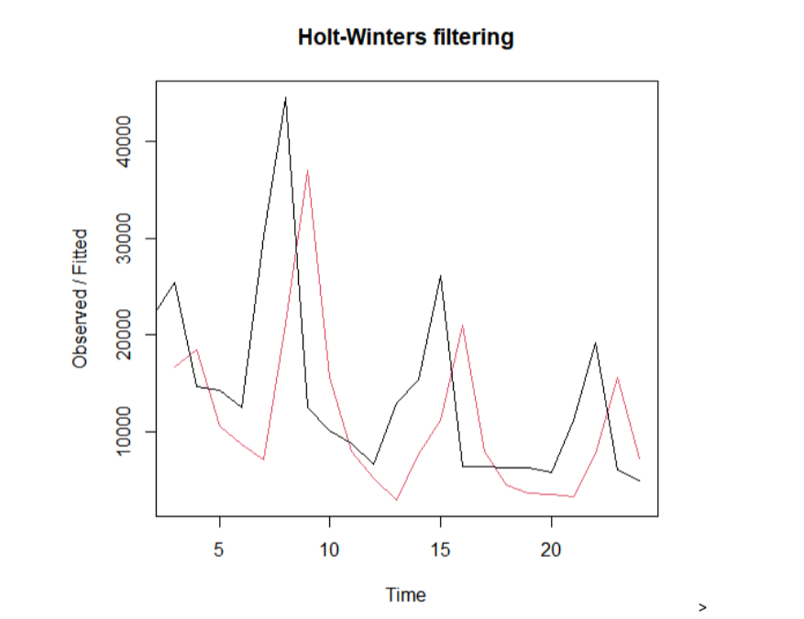

VANAZ AND PHUGEWADI

FITTED GRAPHS

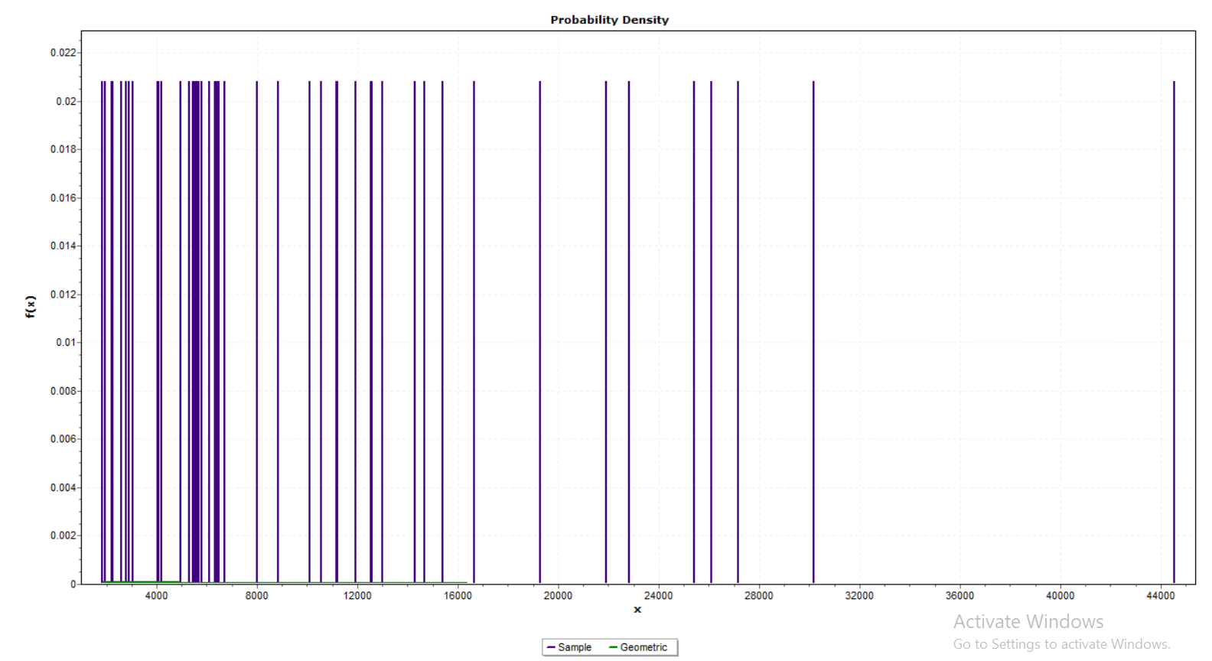

P=9.513E-05

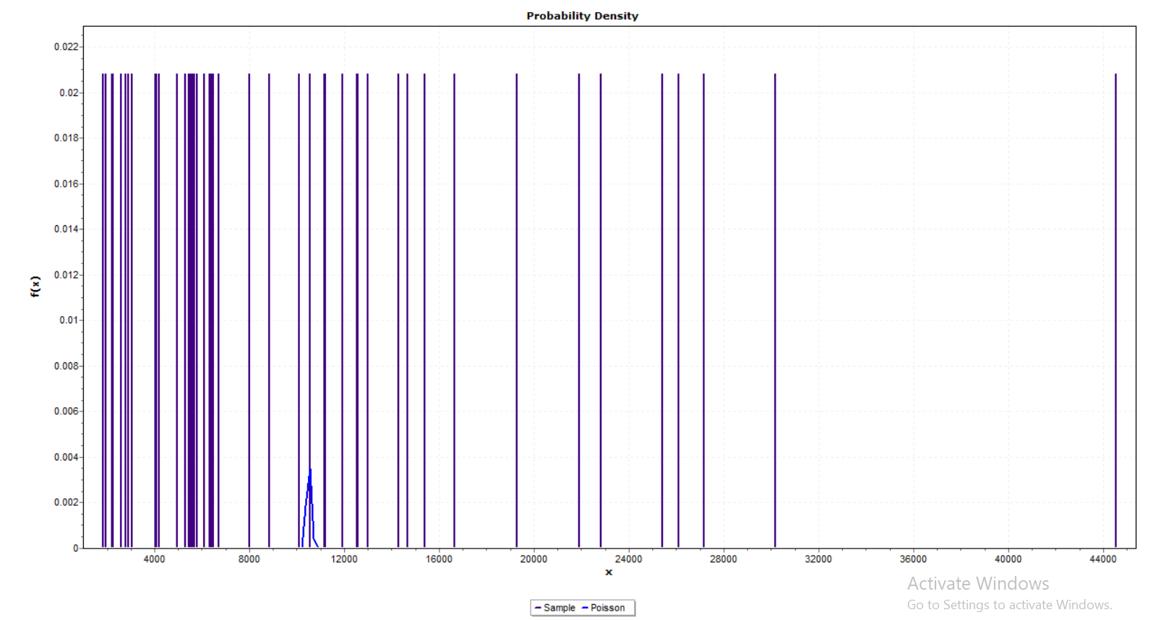

LAMBDA:10511

CONTINOUS:

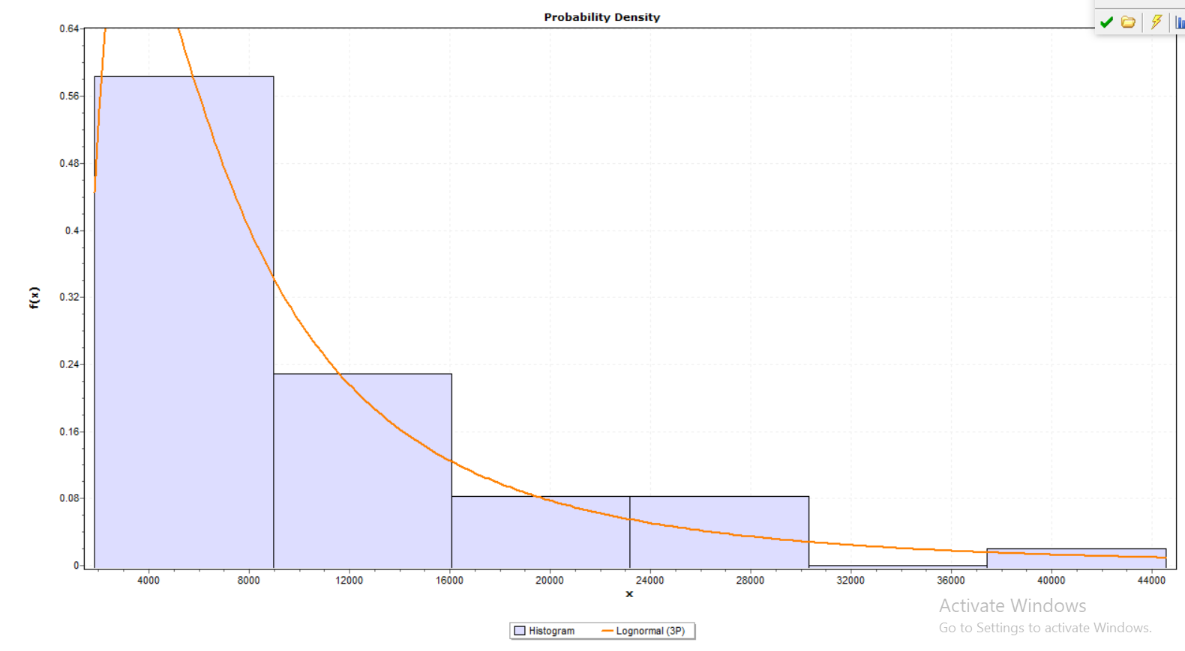

STATISTIC:0.070

AUTO REGRESSIVE

AR MODEL

AR (1) – **Yt=a1 Yt-1 + a2Yt-2+……+akYt-k+b+ε**

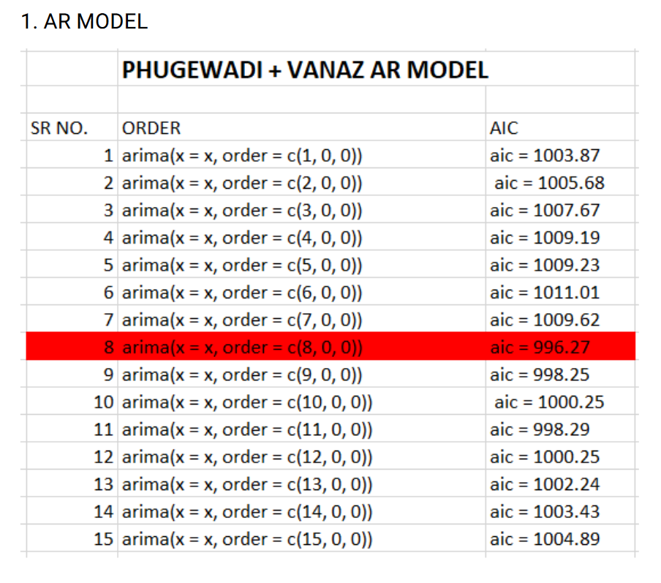

optimum model :arima(b, order = c(8,0,0))

aic = 996.27

**FITTED VALUES –**

|  |  |  |  |
| --- | --- | --- | --- |
| SR NO. | Observed | Expected (AR) | SPILTTED(AR) |
| 1 | 10570 | 10359.637 | 10528.044 |
| 2 | 5688 | 9445.433 | 9447.034 |
| 3 | 16653 | 9814.158 | 10141.782 |
| 4 | 5659 | 11941.362 | 11772.053 |
| 5 | 5566 | 7500.335 | 7665.8 |
| 6 | 4038 | 7455.913 | 7596.93 |
| 7 | 11189 | 7674.165 | 7286.535 |
| 8 | 22814 | 14392.072 | 15302.09 |
| 9 | 5301 | 12885.156 | 12222.103 |
| 10 | 4182 | 11224.2 | 11159.41 |
| 11 | 2912 | 2096.347 | 2468.518 |
| 12 | 2775 | 7291.729 | 7171.704 |
| 13 | 5526 | 7867.776 | 9207.813 |
| 14 | 5461 | 9278.829 | 8634.526 |
| 15 | 11929 | 12784.566 | 12571.189 |
| 16 | 2200 | 1755.457 | 1475.836 |
| 17 | 2241 | 4050.373 | 3837.564 |
| 18 | 1964 | 6220.316 | 6864.28 |
| 19 | 2583 | 5568.201 | 5333.959 |
| 20 | 1849 | 8600.144 | 9358.201 |
| 21 | 4070 | 4119.626 | 3690.118 |
| 22 | 8023 | 9928.038 | 9951.88 |
| 23 | 1944 | 3555.123 | 3346.029 |
| 24 | 3057 | 4985.211 | 5057.201 |
| 25 | 27182 | 6309.202 | 6558.131 |
| 26 | 21917 | 20536.697 | 20534.998 |
| 27 | 25417 | 14430.79 | 14343.846 |
| 28 | 14664 | 18915.846 | 19472.435 |
| 29 | 14308 | 13594.1 | 12992.693 |
| 30 | 12580 | 14099.796 | 16159.67 |
| 31 | 30187 | 12366.158 | 12390.724 |
| 32 | 44536 | 35475.387 | 36448.255 |
| 33 | 12548 | 23885.566 | 22833.283 |
| 34 | 10108 | 10739.343 | 10729.95 |
| 35 | 8832 | 6829.238 | 7448.458 |
| 36 | 6727 | 12714.857 | 12920.367 |
| 37 | 12998 | 11412.02 | 13455.186 |
| 38 | 15384 | 17522.186 | 16312.669 |
| 39 | 26121 | 19166.336 | 18477.159 |
| 40 | 6475 | 2019.254 | 1524.079 |
| 41 | 6401 | 4802.866 | 4326.343 |
| 42 | 6336 | 9990.753 | 9951.999 |
| 43 | 6321 | 7762.423 | 9820.66 |
| 44 | 5780 | 13692.644 | 16282.938 |
| 45 | 11179 | 6534.266 | 11755.171 |
| 46 | 19272 | 16066.237 | 14443.411 |
| 47 | 6096 | 4543.128 | 3717.337 |
| 48 | 4959 | 6605.608 | 4900.074 |
| 49 |  | 8091.221 |  |
| 50 |  | 10071.859 |  |
| 51 |  | 11341.92 |  |
| 52 |  | 11773.043 |  |
| 53 |  | 14553.096 |  |
| 54 |  | 6047.193 |  |
| 55 |  | 7150.322 |  |
| 56 |  | 11212.313 |  |
| 57 |  | 12052.088 |  |
| 58 |  | 12191.248 |  |
| 59 |  | 10183.629 |  |
| 60 |  | 11406.555 |  |

**SPLIT N TEST –**

|  |  |  |
| --- | --- | --- |
| Sr no. | Observed | Expected(AR) |
| 1 | 10570 | 10528.044 |
|  |  |  |
| 2 | 5688 | 9447.034 |
| 3 | 16653 | 10141.782 |
| 4 | 5659 | 11772.053 |
| 5 | 5566 | 7665.8 |
| 6 | 4038 | 7596.93 |
| 7 | 11189 | 7286.535 |
| 8 | 22814 | 15302.09 |
| 9 | 5301 | 12222.103 |
| 10 | 4182 | 11159.41 |
| 11 | 2912 | 2468.518 |
| 12 | 2775 | 7171.704 |
| 13 | 5526 | 9207.813 |
| 14 | 5461 | 8634.526 |
| 15 | 11929 | 12571.189 |
| 16 | 2200 | 1475.836 |
| 17 | 2241 | 3837.564 |
| 18 | 1964 | 6864.28 |
| 19 | 2583 | 5333.959 |
| 20 | 1849 | 9358.201 |
| 21 | 4070 | 3690.118 |
| 22 | 8023 | 9951.88 |
| 23 | 1944 | 3346.029 |
| 24 | 3057 | 5057.201 |
| 25 | 27182 | 6558.131 |
| 26 | 21917 | 20534.998 |
| 27 | 25417 | 14343.846 |
| 28 | 14664 | 19472.435 |
| 29 | 14308 | 12992.693 |
| 30 | 12580 | 16159.67 |
| 31 | 30187 | 12390.724 |
| 32 | 44536 | 36448.255 |
| 33 | 12548 | 22833.283 |
| 34 | 10108 | 10729.95 |
| 35 | 8832 | 7448.458 |
| 36 | 6727 | 12920.367 |
| 37 | 12998 | 13455.186 |
| 38 | 15384 | 16312.669 |
| 39 | 26121 | 18477.159 |
| 40 | 6475 | 1524.079 |
| 41 | 6401 | 4326.343 |
| 42 | 6336 | 9951.999 |
| 43 | 6321 | 9820.66 |
| 44 | 5780 | 16282.938 |
| 45 | 11179 | 11755.171 |
| 46 | 19272 | 14443.411 |
| 47 | 6096 | 3717.337 |
| 48 | 4959 | 4900.074 |

**2. MA MODEL**

**MA (1) = Xt = µ + wt + θ1 wt-1+ θ2 wt-2+…..+ θq wt-q**

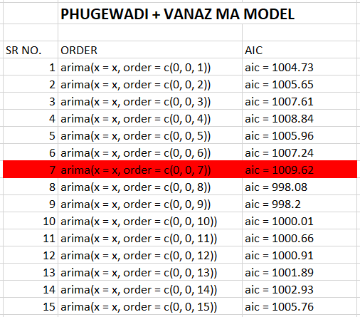

**FITTED VALUES –**

|  |  |  |
| --- | --- | --- |
| sr no | observed | expected (MA) |
| 1 | 10570 | 10195.9342 |
| 2 | 5688 | 9227.9621 |
| 3 | 16653 | 9846.6769 |
| 4 | 5659 | 11437.3133 |
| 5 | 5566 | 7967.7526 |
| 6 | 4038 | 6011.6888 |
| 7 | 11189 | 7976.8119 |
| 8 | 22814 | 13279.2354 |
| 9 | 5301 | 14105.9878 |
| 10 | 4182 | 9933.9986 |
| 11 | 2912 | 988.2075 |
| 12 | 2775 | 7036.1392 |
| 13 | 5526 | 8564.8872 |
| 14 | 5461 | 9778.5342 |
| 15 | 11929 | 9319.578 |
| 16 | 2200 | 1755.0014 |
| 17 | 2241 | 5113.0684 |
| 18 | 1964 | 6827.3696 |
| 19 | 2583 | 1769.9243 |
| 20 | 1849 | 4360.0353 |
| 21 | 4070 | 5612.4332 |
| 22 | 8023 | 8937.7804 |
| 23 | 1944 | 7165.9544 |
| 24 | 3057 | 2643.7343 |
| 25 | 27182 | 5343.2033 |
| 26 | 21917 | 20748.5086 |
| 27 | 25417 | 17084.0427 |
| 28 | 14664 | 14432.3446 |
| 29 | 14308 | 13373.9676 |
| 30 | 12580 | 10735.5496 |
| 31 | 30187 | 20463.6755 |
| 32 | 44536 | 35443.5951 |
| 33 | 12548 | 24551.6732 |
| 34 | 10108 | 14950.9284 |
| 35 | 8832 | 5871.3094 |
| 36 | 6727 | 11946.5038 |
| 37 | 12998 | 12870.4712 |
| 38 | 15384 | 16949.7588 |
| 39 | 26121 | 13042.3899 |
| 40 | 6475 | 5990.0742 |
| 41 | 6401 | 10818.653 |
| 42 | 6336 | 8755.3401 |
| 43 | 6321 | 4301.8897 |
| 44 | 5780 | 10234.4122 |
| 45 | 11179 | 11102.1577 |
| 46 | 19272 | 18024.2328 |
| 47 | 6096 | 10209.2553 |
| 48 | 4959 | 3747.7375 |
| 49 |  | 6011.679 |
| 50 |  | 6791.907 |
| 51 |  | 72410274 |
| 52 |  | 7259.886 |
| 53 |  | 7288.524 |
| 54 |  | 7318.912 |
| 55 |  | 7590.838 |
| 56 |  | 8922.716 |
| 57 |  | 8941.784 |
| 58 |  | 8941.784 |
| 59 |  | 8941.784 |
| 60 |  | 8941.784 |

**SPILT N TEST-**

|  |  |  |
| --- | --- | --- |
| Sr no. | Observed | Expected(MA) |
| 1 | 10570 | 10658.2381 |
| 2 | 5688 | 9309.114 |
| 3 | 16653 | 10277.0546 |
| 4 | 5659 | 11194.0361 |
| 5 | 5566 | 8233.8092 |
| 6 | 4038 | 5929.2727 |
| 7 | 11189 | 7966.409 |
| 8 | 22814 | 13641.0829 |
| 9 | 5301 | 14030.6882 |
| 10 | 4182 | 10546.663 |
| 11 | 2912 | 1403.0667 |
| 12 | 2775 | 6609.6837 |
| 13 | 5526 | 7810.3425 |
| 14 | 5461 | 8526.401 |
| 15 | 11929 | 8256.4665 |
| 16 | 2200 | 944.8941 |
| 17 | 2241 | 5024.6262 |
| 18 | 1964 | 7199.2504 |
| 19 | 2583 | 2687.2995 |
| 20 | 1849 | 5022.9949 |
| 21 | 4070 | 6143.7582 |
| 22 | 8023 | 8734.1638 |
| 23 | 1944 | 6253.9516 |
| 24 | 3057 | 1709.0344 |
| 25 | 27182 | 4912.6099 |
| 26 | 21917 | 19783.369 |
| 27 | 25417 | 18557.6662 |
| 28 | 14664 | 16939.0274 |
| 29 | 14308 | 17520.3918 |
| 30 | 12580 | 14526.1259 |
| 31 | 30187 | 23288.4637 |
| 32 | 44536 | 35565.507 |
| 33 | 12548 | 23218.3469 |
| 34 | 10108 | 14000.0955 |
| 35 | 8832 | 4242.7576 |
| 36 | 6727 | 9853.9624 |
| 37 | 12998 | 11883.1109 |
| 38 | 15384 | 16415.7495 |
| 39 | 26121 | 13931.4842 |
| 40 | 6475 | 6837.2084 |
| 41 | 6401 | 13657.26 |
| 42 | 6336 | 15359.48 |
| 43 | 6321 | 12438.87 |
| 44 | 5780 | 14911.5 |
| 45 | 11179 | 16237.4 |
| 46 | 19272 | 21296.61 |
| 47 | 6096 | 11520.47 |
| 48 | 4959 | 10689.62 |

ARMA

|  |  |
| --- | --- |
| **Combine** | |
| ***ARIMA Model*** | ***AIC*** |
| arima(x = t, order = c(1, 0, 8)) | 996.23 |
| arima(x = t, order = c(2, 0, 8)) | 998.05 |
| arima(x = t, order = c(3, 0, 9)) | 1000.73 |
| arima(x = t, order = c(4, 0, 7)) | 1001.88 |
| arima(x = t, order = c(5, 0, 5)) | 999.83 |
| arima(x = t, order = c(6, 0, 4)) | 1001.77 |
| arima(x = t, order = c(7, 0, 5)) | 999.19 |
| arima(x = t, order = c(8, 0, 6)) | 997.28 |
| arima(x = t, order = c(9, 0, 3)) | 997.47 |
| arima(x = t, order = c(10, 0, 1)) | 999.19 |

Model Fitting-

Model = arima(x = t, order = c(1, 0, 8))

AIC = 996.23

|  |  |  |
| --- | --- | --- |
|  | Observed | Expected |
| 1 | 10570 | 10267.12 |
| 2 | 5688 | 9128.026 |
| 3 | 16653 | 9899.133 |
| 4 | 5659 | 12043.98 |
| 5 | 5566 | 6674.91 |
| 6 | 4038 | 7343.237 |
| 7 | 11189 | 7423.188 |
| 8 | 22814 | 14459.86 |
| 9 | 5301 | 13198.15 |
| 10 | 4182 | 8940.344 |
| 11 | 2912 | 2247.893 |
| 12 | 2775 | 5821.912 |
| 13 | 5526 | 9111.64 |
| 14 | 5461 | 8911.215 |
| 15 | 11929 | 9990.49 |
| 16 | 2200 | 1910.146 |
| 17 | 2241 | 4725.145 |
| 18 | 1964 | 6758.108 |
| 19 | 2583 | 2031.347 |
| 20 | 1849 | 4262.307 |
| 21 | 4070 | 5591.026 |
| 22 | 8023 | 8821 |
| 23 | 1944 | 7100.89 |
| 24 | 3057 | 2112.839 |
| 25 | 27182 | 6934.709 |
| 26 | 21917 | 21580.03 |
| 27 | 25417 | 15589.26 |
| 28 | 14664 | 16734.69 |
| 29 | 14308 | 11238.45 |
| 30 | 12580 | 13024.08 |
| 31 | 30187 | 19229.74 |
| 32 | 44536 | 37066 |
| 33 | 12548 | 23796.94 |
| 34 | 10108 | 12512.82 |
| 35 | 8832 | 9085.262 |
| 36 | 6727 | 8768.417 |
| 37 | 12998 | 15247.02 |
| 38 | 15384 | 14740.98 |
| 39 | 26121 | 15516.82 |
| 40 | 6475 | 5279.884 |
| 41 | 6401 | 11283.91 |
| 42 | 6336 | 7699.722 |
| 43 | 6321 | 5875.599 |
| 44 | 5780 | 8905.324 |
| 45 | 11179 | 11867.45 |
| 46 | 19272 | 17131.43 |
| 47 | 6096 | 11110.18 |
| 48 | 4959 | 1828.836 |
| 49 |  | 5707.392 |
| 50 |  | 6784.68 |
| 51 |  | 7029.752 |
| 52 |  | 7102.948 |
| 53 |  | 7105.925 |
| 54 |  | 7172.792 |
| 55 |  | 7399.163 |
| 56 |  | 8659.193 |
| 57 |  | 8706.703 |
| 58 |  | 8736.899 |
| 59 |  | 8756.121 |
| 60 |  | 8768.37 |

Split, Train and Test-

|  |  |  |
| --- | --- | --- |
|  | b | d |
| 1 | 10570 | 10657.55 |
| 2 | 5688 | 9182.658 |
| 3 | 16653 | 10306.2 |
| 4 | 5659 | 11786.83 |
| 5 | 5566 | 6942.823 |
| 6 | 4038 | 7052.726 |
| 7 | 11189 | 7346.989 |
| 8 | 22814 | 14789.9 |
| 9 | 5301 | 13093.76 |
| 10 | 4182 | 9457.497 |
| 11 | 2912 | 2541.036 |
| 12 | 2775 | 5549.657 |
| 13 | 5526 | 8483.718 |
| 14 | 5461 | 7751.273 |
| 15 | 11929 | 8966.178 |
| 16 | 2200 | 1212.179 |
| 17 | 2241 | 4455.19 |
| 18 | 1964 | 6988.739 |
| 19 | 2583 | 2783.233 |
| 20 | 1849 | 4768.763 |
| 21 | 4070 | 6069.673 |
| 22 | 8023 | 8601.256 |
| 23 | 1944 | 6228.834 |
| 24 | 3057 | 1370.791 |
| 25 | 27182 | 6413.089 |
| 26 | 21917 | 20833.88 |
| 27 | 25417 | 17111.84 |
| 28 | 14664 | 18874.04 |
| 29 | 14308 | 15254.08 |
| 30 | 12580 | 16541.44 |
| 31 | 30187 | 21793.06 |
| 32 | 44536 | 37386.59 |
| 33 | 12548 | 22595.06 |
| 34 | 10108 | 11483.51 |
| 35 | 8832 | 7446.41 |
| 36 | 6727 | 7132.421 |
| 37 | 12998 | 14140.83 |
| 38 | 15384 | 14561.83 |
| 39 | 26121 | 16092.55 |
| 40 | 6475 | 6305.696 |
| 41 | 6401 | 13867.92 |
| 42 | 6336 | 14929.08 |
| 43 | 6321 | 12912.3 |
| 44 | 5780 | 14196.74 |
| 45 | 11179 | 16827.38 |
| 46 | 19272 | 20309.44 |
| 47 | 6096 | 12434.52 |
| 48 | 4959 | 9508.574 |

**3. EXPONENTIAL MODEL-**

**FITTED VALUES-**

|  |  |  |
| --- | --- | --- |
| Sr no. | Observed | Expected (Expo) |
| 1 | 10570 | 10570 |
| 2 | 5688 | 6664.4 |
| 3 | 16653 | 14655.28 |
| 4 | 5659 | 7458.256 |
| 5 | 5566 | 5944.451 |
| 6 | 4038 | 4419.29 |
| 7 | 11189 | 9835.058 |
| 8 | 22814 | 20218.212 |
| 9 | 5301 | 8284.442 |
| 10 | 4182 | 5002.488 |
| 11 | 2912 | 3330.098 |
| 12 | 2775 | 2886.02 |
| 13 | 5526 | 4998.004 |
| 14 | 5461 | 5368.401 |
| 15 | 11929 | 10616.88 |
| 16 | 2200 | 3883.376 |
| 17 | 2241 | 2569.475 |
| 18 | 1964 | 2085.095 |
| 19 | 2583 | 2483.419 |
| 20 | 1849 | 1975.884 |
| 21 | 4070 | 3651.177 |
| 22 | 8023 | 7148.635 |
| 23 | 1944 | 2984.927 |
| 24 |  | 3042.585 |
| 25 |  | 3042.585 |
| 26 |  | 3042.585 |
| 27 |  | 3042.585 |
| 28 |  | 3042.585 |
| 29 |  | 3042.585 |
| 30 |  | 3042.585 |
| 31 |  | 3042.585 |
| 32 |  | 3042.585 |
| 33 |  | 3042.585 |
| 34 |  | 3042.585 |
| 35 |  | 3042.585 |

**SPILT N TEST-**

|  |  |  |
| --- | --- | --- |
| Sr no. | Observed | Expected(expo) |
| 1 | 10570 | 10570 |
| 2 | 5688 | 6664.4 |
| 3 | 16653 | 14655.28 |
| 4 | 5659 | 7458.256 |
| 5 | 5566 | 5944.451 |
| 6 | 4038 | 4419.29 |
| 7 | 11189 | 9835.058 |
| 8 | 22814 | 20218.212 |
| 9 | 5301 | 8284.442 |
| 10 | 4182 | 5002.488 |
| 11 | 2912 | 3330.098 |
| 12 | 2775 | 2886.02 |
| 13 | 5526 | 4998.004 |
| 14 | 5461 | 5368.401 |
| 15 | 11929 | 10616.88 |
| 16 | 2200 | 3883.376 |
| 17 | 2241 | 2569.475 |
| 18 | 1964 | 2085.095 |
| 19 | 2583 | 2483.419 |
| 20 | 1849 | 1975.884 |
| 21 | 4070 | 3651.177 |
| 22 | 8023 | 7148.635 |
| 23 | 1944 | 2984.927 |
| 24 | 3057 | 3042.585 |
| 25 | 27182 | 3042.585 |
| 26 | 21917 | 3042.585 |
| 27 | 25417 | 3042.585 |
| 28 | 14664 | 3042.585 |
| 29 | 14308 | 3042.585 |
| 30 | 12580 | 3042.585 |
| 31 | 30187 | 3042.585 |

**4. HOLTWINTERS MODEL –**

**FITTED VALUES-**

|  |  |  |
| --- | --- | --- |
| Sr no. | observed | expected (Holt) |
|  |  |  |
| 1 | 10570 | 806 |
| 2 | 5688 | 6158.1551 |
| 3 | 16653 | 1974.9836 |
| 4 | 5659 | 401.121 |
| 5 | 5566 | -911.7163 |
| 6 | 4038 | 3475.8415 |
| 7 | 11189 | 13317.1894 |
| 8 | 22814 | 6738.9787 |
| 9 | 5301 | 3169.8154 |
| 10 | 4182 | 920.7024 |
| 11 | 2912 | 18.9999 |
| 12 | 2775 | 1595.7419 |
| 13 | 5526 | 2467.1037 |
| 14 | 5461 | 7201.9109 |
| 15 | 11929 | 3205.572 |
| 16 | 2200 | 1494.2625 |
| 17 | 2241 | 647.0874 |
| 18 | 1964 | 777.0533 |
| 19 | 2583 | 473.8122 |
| 20 | 1849 | 1869.8287 |
| 21 | 4070 | 5148.9113 |
| 22 | 8023 | 2780.9614 |
| 23 | 1944 | 2454.5187 |
| 24 | 3057 | 17936.8565 |
| 25 | 27182 | 21613.801 |
| 26 | 21917 | 25432.9553 |
| 27 | 25417 | 20086.3428 |
| 28 | 14664 | 17268.7625 |
| 29 | 14308 | 14782.4853 |
| 30 | 12580 | 24970.5066 |
| 31 | 30187 | 38838.4046 |
| 32 | 44536 | 24352.9028 |
| 33 | 12548 | 15952.3439 |
| 34 | 10108 | 11234.95 |
| 35 | 8832 | 7745.8287 |
| 36 | 6727 | 10269.3994 |
| 37 | 12998 | 13042.5779 |
| 38 | 15384 | 21288.4612 |
| 39 | 26121 | 12364.2598 |
| 40 | 6475 | 8201.0229 |
| 41 | 6401 | 6300.1943 |
| 42 | 6336 | 5497.0702 |
| 43 | 6321 | 4864.5692 |
| 44 | 5780 | 8145.5056 |
| 45 | 11179 | 14941.0268 |
| 46 | 19272 | 9555.7312 |
| 47 |  | 6344.0509 |
| 48 |  | 5804.7713 |
| 49 |  | 5265.4917 |
| 50 |  | 4726.212 |
| 51 |  | 4186.9324 |
| 52 |  | 3647.6528 |
| 53 |  | 3108.3731 |
| 54 |  | 2569.0935 |
| 55 |  | 2029.8139 |
| 56 |  | 1490.5343 |
| 57 |  | 951.2546 |
| 58 |  | 411.975 |

**SPILT N TEST –**

|  |  |  |
| --- | --- | --- |
| Sr no. | Observed | Expected(Holt) |
| 1 | 10570 | 806 |
| 2 | 5688 | 5732.955 |
| 3 | 16653 | 1886.6099 |
| 4 | 5659 | 358.4585 |
| 5 | 5566 | -918.5102 |
| 6 | 4038 | 3272.3534 |
| 7 | 11189 | 12891.0299 |
| 8 | 22814 | 7049.339 |
| 9 | 5301 | 3612.934 |
| 10 | 4182 | 1321.8145 |
| 11 | 2912 | 316.2158 |
| 12 | 2775 | 1735.0399 |
| 13 | 5526 | 2590.9348 |
| 14 | 5461 | 7174.8701 |
| 15 | 11929 | 3536.6523 |
| 16 | 2200 | 1836.2966 |
| 17 | 2241 | 928.5498 |
| 18 | 1964 | 974.5414 |
| 19 | 2583 | 650.6379 |
| 20 | 1849 | 1961.6502 |
| 21 | 4070 | 5141.3407 |
| 22 | 8023 | 3003.7382 |
| 23 | 1944 | 2659.9962 |
| 24 | 3057 | 17465.5183 |
| 25 | 27182 | 21521.2466 |
| 26 | 21917 | 25536.7691 |
| 27 | 25417 | 20676.7453 |
| 28 | 14664 | 17862.6364 |
| 29 | 14308 | 15286.1896 |
| 30 | 12580 | 24842.368 |
| 31 | 30187 | 38382.0623 |
| 32 | 44536 | 25085.0184 |
| 33 | 12548 | 16745.2842 |
| 34 | 10108 | 11755.7887 |
| 35 | 8832 | 8011.7158 |
| 36 | 6727 | 10123.5846 |
| 37 | 12998 | 12745.409 |
| 38 | 15384 | 20749.3354 |
| 39 | 26121 | 12551.32 |
| 40 | 6475 | 12214.71 |
| 41 | 6401 | 11878.1 |
| 42 | 6336 | 11541.49 |
| 43 | 6321 | 11204.88 |
| 44 | 5780 | 10868.27 |
| 45 | 11179 | 10531.66 |
| 46 | 19272 | 10195.05 |

**Statistical Techniques Used:**

* Time Series
* Model fitting
* Kolmogorov-Smirnov Test
* Mann-Kendall Test

**Softwares Used:**

* Excel
* R
* Easy Fit

**CONCLUSION**

 This study has discussed the application of test series about “Pune Metro”. From the result obtained that there is a decreasing number of passengers.

·        According to the data study it is observed that there is a increase in number of passengers on weekends.

·        The best fitted model according to the study is

Phugewadi - ARMA

Vanaz - AR

Pune - AR

·        So from the analysis there is a need to increase awareness among people about metro and its usage.

**LIMITATIONS :**

The only limitation of this project is that there are only two station’s information data is available

**Report issued by Times of India**



**THANK YOU**